**Ages 3-5**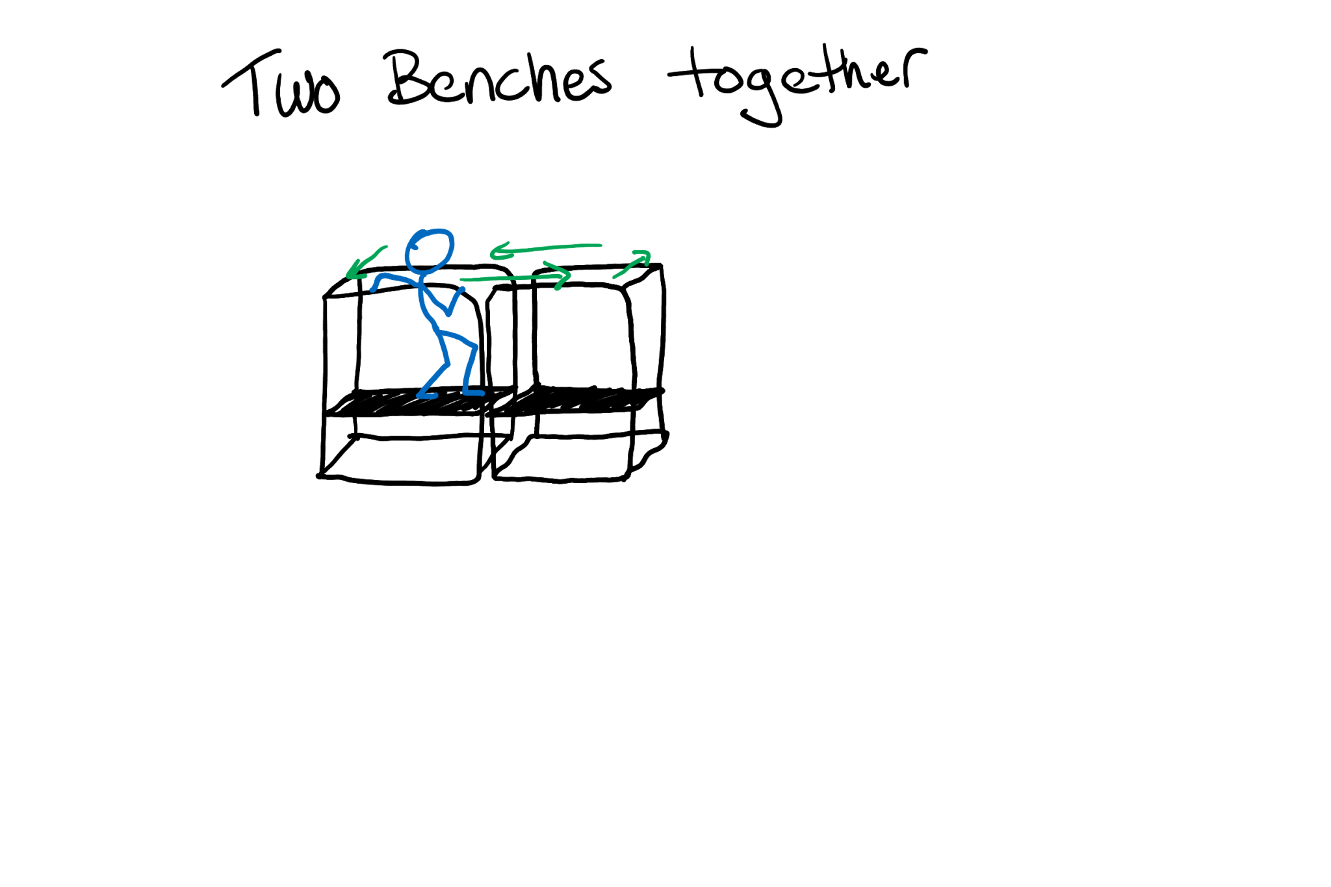

**Common issues and fixes:**

**Inability to stand upright on your own:** Benches raise the bottom and make it shallower for swimmers / use the shallow end.

**Difficulty following directions:** Create buy-in, make things interesting, be a dynamic person, make it fun, play with them, foster listening to the leader because the leader will do something fun.

**Lack of body control**: Make swimming a game even if they can’t do the fine point motions then focus on macro movements; keep their body still. \****You won swim lessons*\*** Do what they CAN do.

**Fear of the water, discomfort, unfamiliar with pool water and environment:** Avoid pushing swimmers into their discomfort; refusing to go underwater then gradually push it and do alternate or modified skills to their level of comfort.

EX: Use the structure of swim lessons (sequence for going underwater)

1. Chest
2. Shoulders
3. Chin
4. Lips
5. Nose
6. Eyes
7. Whole head

**Afraid of strangers:** Using the same lesson plan, same formula, same structure, same scripts, consistency is KEY.

**Does not listen:** Make it interesting for the swimmer. Keep them engaged. Do not be boring. They won’t care. Be dynamic, exciting, motivated, involved, be an active participant in the lesson. If you are willing to go under, they will too. Demonstrate all things you’re asking them to do. They won’t do it right because they don’t have context because they’ve never seen it before. Demo first! Then they know and can emulate.

EX: Show them how you put your head underwater and always have your shoulders under water.

**Ages 8-12**

**Common issues and fixes:**

**Terrified of the water (stems from fear):** Modify activities to still participate even if not going underwater. Create trust between swimmer and instructor to eventually go under. Instructors should participate in activities to show that water is not scary.

**Refusing to participate:** If they refuse to do an activity alter the activity to their comfort level

EX: Do a supported front glide if they refuse do a supported front glide without face in water or a hug moving across the pool.

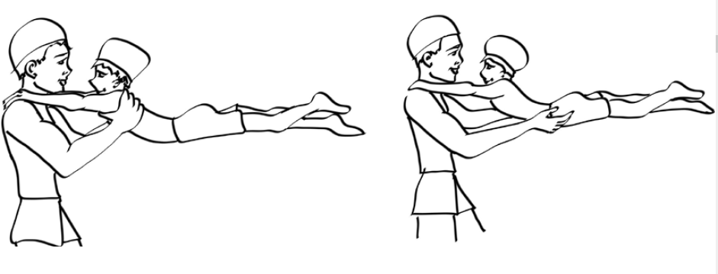

**Disruptive behavior:** Provide rewards for good behavior.

EX: personalized challenge.

**Escalating bad behavior -> tell LC -> continued bad behavior tell parents**