**Ages 3-5**

**Common issues and fixes:**

**Younger/smaller than the other swimmers in the group:** They have less stamina they may have to swim shorter distances. Take breaks often and tell them that at any point they can take a break if they need to.

EX: If doing 3X streamline and 3X arms to the flags if they can’t do it move the bench closer.

**Lack of body control:**  Don’t focus on the small details of the strokes.

EX: How their hands should exactly scoop the water during FR arm circles. Focus on the bigger picture before mastering details.

EX: Learn the circular motion of FR arms but don’t focus too much on finger placement and details.

**Difficulty following directions:** Use simple direct words and do not explain in depth. Use words they understand and make it clear that they can ask questions at any time.

EX: Turn away from me, put your shoulders in the water, tilt your head back, and push off with me (supported back glide script)

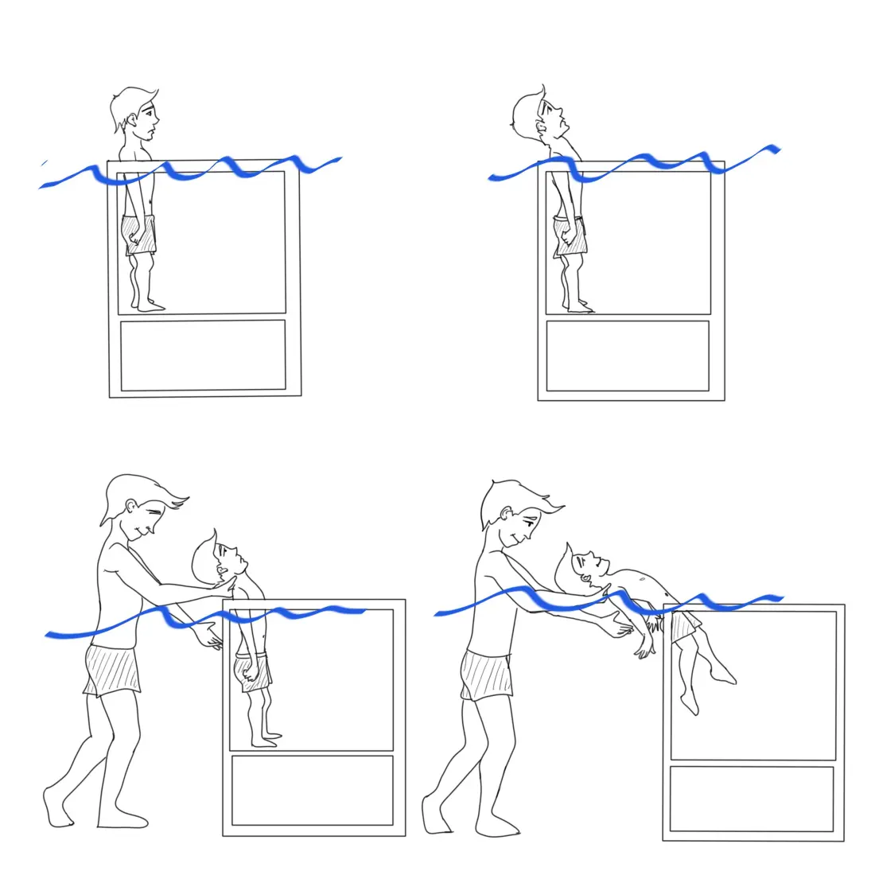

**Distracted easily / difficulty paying attention:** Always have something for them to do. If they are not the one swimming, tell them to do 5 bobs and then it will be their turn. KEEP THEM BUSY!!!

**Ages 5-7**

**Common issues and fixes:**

**Don’t follow directions:** Use rewards for them this could mean praise after swimming well or a game/fun activity at the end. Use games that practice swimming but also are fun to them. They won’t follow directions if they're bored.

EX: Challenges

**Becoming independent:** 5-7 year olds developmentally are becoming independent at this age this may mean they don’t want any help, still always offer assistance and be right next to them as they are swimming if they are not fully confident.

EX: As they do FR, walk with them on the side of them.

**Hesitant to try new things:**  Don’t introduce too much at once, it's overwhelming. Build onto new skills over time/start small until a bigger goal or skill has been reached then reward for what was tried. Chunking skills and building over time

EX: Streamline -> FR arms -> FR kick -> Put it all together to do FR

**Ages 8-12**

**Common issues and fixes:**

**Older than other kids:** Talk to them like they are 8-12 not younger, just because they are not a strong swimmer doesn’t mean they shouldn’t be treated their age.

**Quiet and shy:** Make sure everyone in the group is comfortable around each other. Introduce yourself and others. Use activities that make the kids talk to each other so they can feel more comfortable being social.

**Too social:** Make it a point to have the kids understand that there is a time and place for talking. Talking is okay when waiting to swim but as soon as it is their turn they must be ready to swim.

**Talking back/attitude:** Make it clear that you are the one leading the lesson and no one else. Do not engage when given an attitude, only engage when they follow directions and speak nicely. They will learn that you respond to good behavior.

**For all of the above: use the structure of swim lessons/ activity, activity, challenge, and circle swimming because there is time built in for socializing and swimming.**