**Ages 5-7**

**Common issues and fixes:**

**Very young:** Kids ages 5-7 in level 4 are most likely the youngest kids in the group. Keep that in mind and know that you may have to test their limits because there can be a wide range of abilities of these kids.

**Distracted easily:** Although these kids are better swimmers it is hard for young kids to stay on task for long periods of time. Follow the lesson plans and formula, move quickly through activities.

**No stamina:** Kids of such a young age can not swim as far as an older kid. Keep that in mind and have them practice their skills in shorter distances. **Consider adding a bench.**

**No technique:** A young child can not create the small little details with their bodies while they do the strokes but they can learn them. As an instructor, always talk about them and demonstrate them even if they can not physically possibly do it.

EX: Show how the elbow should bend for a FR arm circle but the child might focus on just having a big arm circle.

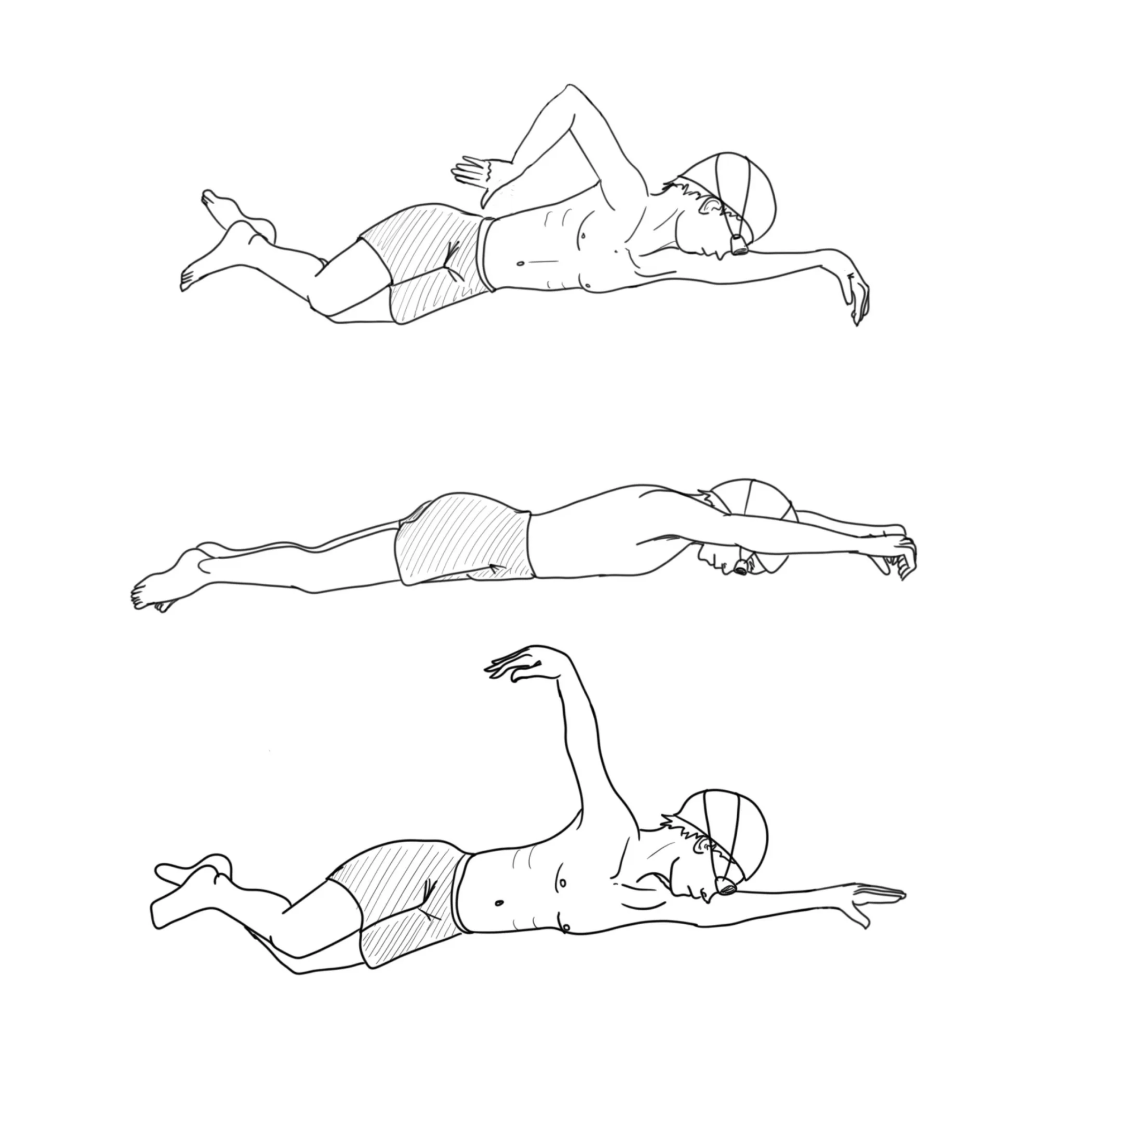

**Ages 8-12**

**Common issues and fixes:**

**Negative attitude:**  Kids of this age often have the attitude of “I can’t do it” or “this is impossible” at this level kids will be trying harder strokes and working on technique so as an instructor you need to enforce the attitude of “yes you can”, “you got this”, “nothing is impossible” even if you sound funny saying these things it can really switch a child's mindset. **Chunk the skill.**

**Don’t get along with others:** At this age for kids they tend to fight with others or make comments that hurt others. As an instructor try to control out of pocket comments by providing your attention not only to their swimming but also the small conversation that may come throughout the lesson. Make sure kids aren’t saying anything hurtful to others and if it does happen explain why it is not okay and can’t happen again.

**Ages 11-13**

**Common issues and fixes:**

**On the older side for swim lessons:** Treat them like it’s swim practice, challenge them so they can improve.

**Disrespectful/rude:** These kids know how to be nasty and speak to you in a rude way, set boundaries and do not put up with that behavior. Report things to LC if it continues then parents.

**Close in age to instructor:** If possible have an older instructor, otherwise treat them like their age if not older, they are almost adults.