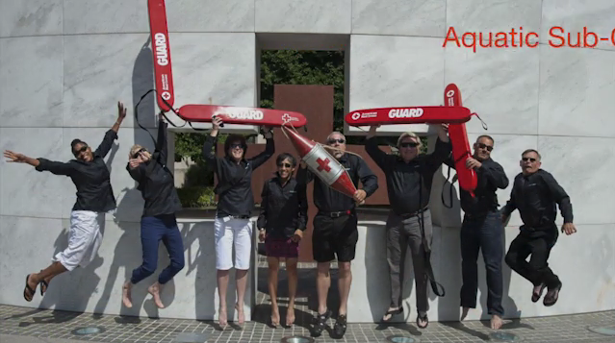

* Familiarize yourself with statutes of IL and the national swimming pool website
* ⅛ pools close after not passing the health inspections, but 300 mil ppl in US enjoy going to pools

\*bubble noises\*

* Lifeguard managers cannot utilize humor according to the red cross
* Coming to work late, starting rotations late, not enforcing rules: traits that coworkers dislike, therefore traits that headguards shouldn’t portray those traits
* Incorporating questions from the lifeguard certification test into trainings (maybe even if someone fails a timmy and they need to have their skills fixed)
* Have headguards play a bigger role in all trainings, giving them a chance to teach new guards what they think will be the most important
* Don’t have the luxury of having a bad day, because lives are always on the line
* Informing, Educating, Enforcing
  + Feet first please rather than no diving →positive rather than negative
  + How to deal with an unruly patron:
    - Know how to stay calm to defuse the situation
    - Don’t overreact
    - Find neutral ground and maintain nonthreatening posture
    - Focus on behavior, not the individual
    - Show respect for the patron
    - Be firm and friendly
    - Use suspension or dismissal as last resort
    - Recognize situation as a learning experience
* Make sure that even when you are on your breaks you are glancing out at the pool deck to notice any lifeguards not looking at their zone, talking to someone else, or who have a cell phone or airpods on their person in the stand
* Chaperone-party goer ratio, you can require chaperones at pool parties so that they don’t get out of hand
* Exercising during a break can help you combat fatigue
* Incident reports are very important (create a map of where the incidents occurred and how many times in order to assess urgency or problem areas)
* 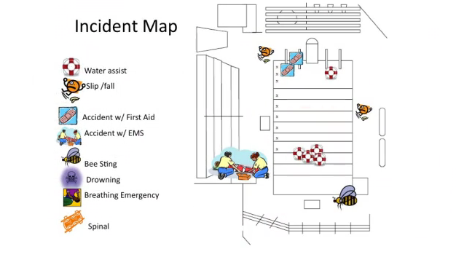
* Facility evacuation map
* IDEA: There is one break in particular that is in charge of any First Aid that is needed
* When you are explaining something to another guard whether on shift or at a training make sure to use a strong confident voice
* During or after an incident lifeguards should refer the press to the media spokesperson and should avoid discussing the emergency with anyone who is not staff or EMS
* Critical Incident stress - stress experienced after a major incident, can increase if someone believes that they made a mistake
  + Keep debrief positive
  + Confusion, shortened attention span, denial, guilt, depression, anger, changes in interactions, changes in appetite, other uncharacteristic behavior
  + Emphasise that it is not a sign of weakness
  + Ways to avoid: slow deep breathing, nutritious meals, low amts of caffeine, exercise
* If a person says that they are a medical professional, do not let them take over the scene or touch the victim unless they are with EMS
* Use direct quotes when possible when filling out an incident report
* “Treat others how you would want to be treated,” and have empathy, remember what it was like before you became a headguard and what challenges you may have faced in order to best support the lifeguarding staff
* Be an advocate for the lifeguards, ask them their frustrations because you can represent them in leadership meetings
* Communication techniques:
  + Say what you mean
  + Get right to the point
  + Allow communication in both directions
  + Be specific
  + Ask open ended questions
  + Be ready to explain things many times in different ways
* You are like a mentor for other lifeguards, get them involved when you can, like showing them how to do the chemicals or even just answering any questions a new hire may have
* E-book has ideas for incentive programs
* There are employee evaluations included in the e-book
* When asking someone to do something, make sure that you have a reason why they are doing that task. Never leverage your leadership position to coerce someone into doing something. Ex. “Why do I need to clean the bathroom?” Bad: “Because I am the Headguard and I am telling you to.” Good: “We had complaints of ringworm and we want to make sure that the locker rooms are as sanitary as possible.”
* Remember what it is like to be an excited patron at the pool
* Document everything
* 