**Cleaning Hours for Deerspring & Mitchell, with Checklist**

**6-9 (DEERSPRING)**

* 4 people per shift (2 per bathroom)

**6:00am-6:10am**

* Deck Cleaning (picking up)

All 4 people pick up all loose trash in the grass, deck, and catch leaves that might be floating at the top of the pool or other trash.

**6:10am - 6:20am**

* Deck Cleaning (trash bins)

2 people then start at opposite sides of the pool and change all the trash & recycling bins

* Return/organize non trash items

Other 2 people will return & organize lost and found items, lifejackets, tubes, & chairs to designated area, and organize them

**6:20 am-7:00 am**

* Deck Cleaning (hosing)

2 people will hose, starting at opposite ends of the pool working there way together to have the entire pool clean

* Vacuum kid, Clean Max’s

1 person will be vacuuming kid and splash pad

1 person will be hosing off and cleaning the filters (if enough hoses)

**7:00am-7:20am**

* Bathroom (cleaning)

2 people per bathroom, both mopping & scrubbing

(starting at the back of the bathroom working toward the door so no contaminating the clean area)

**7:20am-7:50am**

* Bathrooms (Hosing)

One person on housing

One person does surfaces (benches, changing areas, sinks, lockers, toilets)

One person does surfaces

* Benches
  + Changing areas
  + Flat surfaces (sink counters, lockers)

**7:50 am - 8:10 am**

* Bathrooms (Cleaning)

Hosing goes to chrome, porcelain, & refill soap dispenser

Surfaces goes to drains, tampon machines, mirrors, & wipe excess water off toilets (20 minutes)

**8:10 am - 8:40 am**

* Guard Office (Cleaning)

Everyone cleans guard office & entrance fridge, sunscreen, floors, organizing lockers, tubes, & wipe down surfaces

**8:40 am - 9:00 am**

* Janitors closet (Cleaning)

Everyone cleans janitors closet

coil hoses, wipe down, & organize janitors closet

**6-9 (MITCHELL)**

* 4 people per shift (2 per bathroom)

**6:00am-6:10am**

* Deck cleaning (picking up)

All 4 people pick up all loose trash in the grass, deck, and catch leaves that might be floating at the top of the pool or other trash.

**6:10am - 6:20am**

* Deck cleaning (picking up)

2 people then start at opposite sides of the pool and change all the trash & recycling bins

* Return/organize non trash items

Other 2 people will return lost and found items, lifejackets, and tubes to designated area, and organize them

**6:20 am-7:00 am**

* Deck Cleaning (hosing)

2 people will hose, starting at opposite ends of the pool working there way together to have the entire pool clean

* Vacuum kid, Clean Max’s

1 person will be vacuuming kid and splash pad

1 person will be hosing off and cleaning the filters (if enough hoses)

**7:00 am - 8:20 am**

* Bathroom (Cleaning) (20 Minutes Per Bathroom)
* **Stations**
  + **2** people mop/scrub together starting in **girls main bathroom**
  + 1 person does surfaces in **girls family**
  + 1 person does chrome, porcelain, mirrors, & soap dispensers in **boys family**
* After 20 minutes rotate counter clockwise (chrome go to **boys main**, surfaces go to **boys family**, scrubbers go to **girls family**) (repeat until all bathrooms done)

**8:20 am - 9:00 am**

* Bathrooms & Guard Office (Hosing, Cleaning) (20 minutes per bathroom)
* **Mop/scrubbers**
  + Switch to housing (split up: one in **girls main**, one in **boys main**) (20 minutes)
  + Switch to family bathroom housing (10 minutes)
  + Coil hose and organize cleaning closet (10 minutes)
* **People who did chrome and surfaces:**
  + clean guard room (20 minutes) (while others hose main)
  + Pick drains, replace tampon boxes, & wipe excess water off toilets in main bathrooms (10 minutes)
  + Repeat for family bathroom (10 minutes)

**8:15 am-9:00 am**

* Bathrooms (drains, toilets, tampon, surfaces)

Person who did mirror etc does drains and toilets and tampon machines

Person who hosed does surfaces

* Benches
  + Changing areas
  + Flat surfaces (sink counters, lockers)

One person is doing drains, toilets, & tampon machines in main bathrooms

One person is doing surfaces in family

Once done with respective bathrooms, switch so person doing drains etc, goes to family bathroom, person doing surfaces goes to main bathroom

(should be 22.5 minutes per bathroom)

[(LINK TO CHECKLIST FOR DEERSPRING)](https://www.canva.com/design/DAGmgTyYzGQ/H4yeqcsksv9teg7kQ4KQJQ/edit?utm_content=DAGmgTyYzGQ&utm_campaign=designshare&utm_medium=link2&utm_source=sharebutton)

[(LINK TO CHECKLIST FOR MITCHELL)](https://www.canva.com/design/DAGmgrug-oM/1dkNF_NFAleiSQJATm5F2Q/edit?utm_content=DAGmgrug-oM&utm_campaign=designshare&utm_medium=link2&utm_source=sharebutton)

(also both printed on the next page)

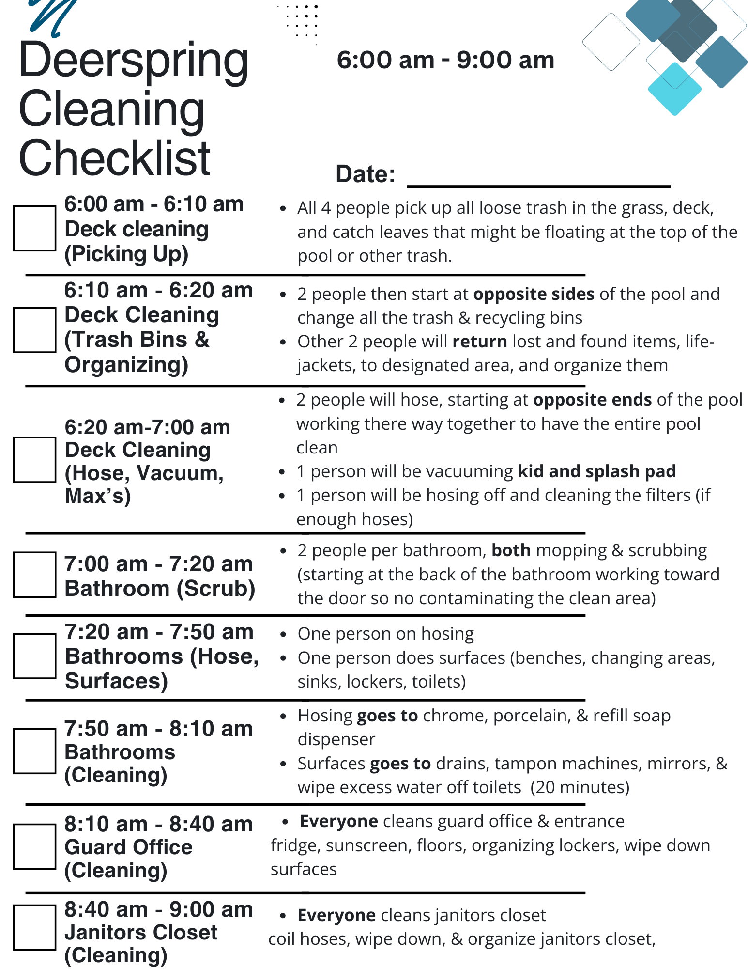

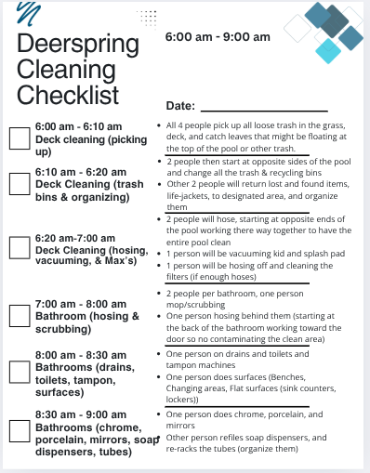

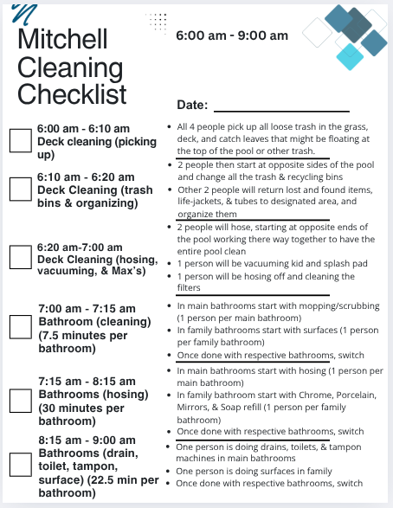

All task needed to be done

* Floors
* Chrome
* Porcelain
* Toilets
* Mirrors
* Refile soap dispensers
* Deck cleaning
  + Trash bin replace
  + Trash on the ground
  + Return lost and found items
  + Return lifejackets to proper place
  + Store and put away all lifeguard tubes
  + Coil the hoses
* Vacuum kid splash pad
* Clean max filters
* Surfaces
  + Benches
  + Changing areas
  + Flat surfaces (sink counters)
* STORE UMBRELLAS
* LAWN CHAIRS
* COIL HOSES (IMPLIED)

Mitchell Pool Cleaning Checklist

| Time | People | Task |
| --- | --- | --- |
| 6:00 am - 6:10 am  Deck Cleaning (Picking up) | Everyone | All 4 people pick up all loose trash in the grass, deck & catch leaves that might be floating at the top of the pool or other trash |
| 6:10 am - 6:20 am  Deck Cleaning (Trash bins & Organizing) | 2 - Trash bins  2 - Organizing | 2 people start at opposite sides of the pool & change all the trash & recycling bins  Other 2 people return & organize life-jackets, chairs, & lost & found items |
| 6:20 am - 7:20 am | 2 - Housing  1 - Vacuum Kid & Splash Pad  1 - Housing & Cleaning Filters | 2 people will hose starting at opposite ends of the pool working there way together to have the entire pool clean  1 person will vacuum kid & splash pad  1 person will be hosing off & cleaning the filters |
| *7:20 am - 8:00 am  (Headguards, finish housing if not done)  7:20 am - 8:00 am  (unit finished)  Bathrooms (Cleaning) | 2 - Mopping & Scrubbing (Together)  1 - Surfaces, Porcelain,  (work with surfaces)  1 - Chrome, Mirrors, & Soap dispensers (work with surfaces) | 2 people do floor scrubbing in womens, mens, family (all bathrooms)  1 people do surfaces, porcelain in womens, mens, families (all bathrooms)  1 person does chrome, mirrors, & soap dispensers in womens, mens, families (all bathrooms) |
| 8:00 am - 9:00 am  Bathrooms & Guard Office (Housing & Cleaning) | 2 - Housing Separately  2 - Clean Guard Office, janitors closet, glove the drain, replace tampon boxes, & wipe excess water off toilets | 2 people house bathrooms in women, mens, families (all bathrooms)  2 people clean guard and janitors closet, swept the floor, look in the fridge, wiped surfaces, and organize closet |

Deerspring Pool Cleaning Checklist

| Time | People | Task |
| --- | --- | --- |
| 6:00 am - 6:10 am  Deck Cleaning (Picking up) | Everyone | All 4 people pick up all loose trash in the grass, deck, and catch leaves that might be floating at the top of the pool or other trash. |
| 6:10 am - 6:20 am  Deck Cleaning (Trash bins & Organizing) | 2 - Housing  2 - Organizing | 2 people start at opposite sides of the pool & change all the trash & recycling bins  Other 2 people return & organize life-jackets, chairs, & lost & found items |
| 6:20 am - 7:50 am  (After 45 minutes housing switch)  Deck cleaning  (housing, kid, splash, filters) | 2 - Housing  1 - Vacuum Kid & Splash Pad  1 - Housing & Cleaning Filters, & picking splash pad drains | 2 people will hose  1 person will vacuum kid & splash pad  1 person will be hosing off & cleaning the filters & picking splash pad drains |
| 7:50 am - 8:00 am  Bathroom (Scrubbing & Mopping) | 2 people per bathroom  Both mopping & Scrubbing | 2 people per bathroom, both mopping & scrubbing starting at the back of the bathroom working toward the door to not contaminate the already scrubbed area |
| 8:00 am - 8:40 am  Bathroom (Hose & Surfaces) | 2 People per bathroom  1 - Housing  1 - Surfaces & Porcelain | 1 Person will be housing the entire bathroom  1 person cleans all surfaces, & porcelain |
| 8:40 am - 8:50 am  Bathrooms (Cleaning) | 1 - Chrome, Refill Soap dispenser  1 - Drains, tampon machines, mirrors, wipe off toilets | Housing person will do chrome porcelain, and refill soap dispensers  Surfaces will pick rains, tampon boxes, wipe mirrors and excess water off toilets |
| 8:50 am - 9:00 am  Guard Office, & Janitors Closet (Cleaning) | Everyone | Clean guard office, & janitors closet, front entrance, fridge, sunscreens, floors, organize lockers, tubes, and wipe down surfaces |